
Work Instruction for HPE Firmware Upgrade Activity

Viatris
Work Instruction for HPE Firmware Upgrade Activity

Contents
Contents 2
1. Introduction 3
1.1. Purpose 3
1.2. Scope of this Report 3
1.3. Audience 3
2.0 Approach and Methodology 3
2.1 Approach 3
3. Technical Details 4
4. Roles and Responsibilities 14
5. Escalation Matrix 14
6. Related Documentation 15
6.1. Additional Documentation 15
7. Version Control 15

1. Introduction

1.1. Purpose
This document will provide the procedure to be followed for HPE firmware upgrade activity.

1.2. Scope of this Report
What this document covers:
The purpose of this guide is to provide details on how HPE firmware upgrade activity.
Usage Expectations:
This document covers end-to-end support guidelines for performing HPE firmware upgrade activity.

1.3. Audience
GIDC Unix Group

2.0 Approach and Methodology

. Approach
    - Backup the operating system (Boot disk).
    - Download the SOS report and AHS logs from HPE server.
    - Subscribe the OS with RedHat portal
# subscription-manager refresh
# subscription-manager list
# yum clean all
# yum repolist
2.2. Methodology
    - Download the required ISO from the HPE portal and mount it on the server console.
    - Reboot the server and select the necessary fields in the console and ISO.
    - Select the type of firmware upgrade and reboot the server after completing the deployment.
    - Login to the RHEL, update and reboot the O.S.

3. Technical Details
3.1. Step 1
3.1.1 Download the SSP ISO from the HPE portal
https://support.hpe.com/connect/s/softwaredetails?language=en_US&softwareId=MTX_50b300127e24428582ca72564a&_sm_au_=iVVWn4SqtFS8V8nqHGJk8Ks61Hf31

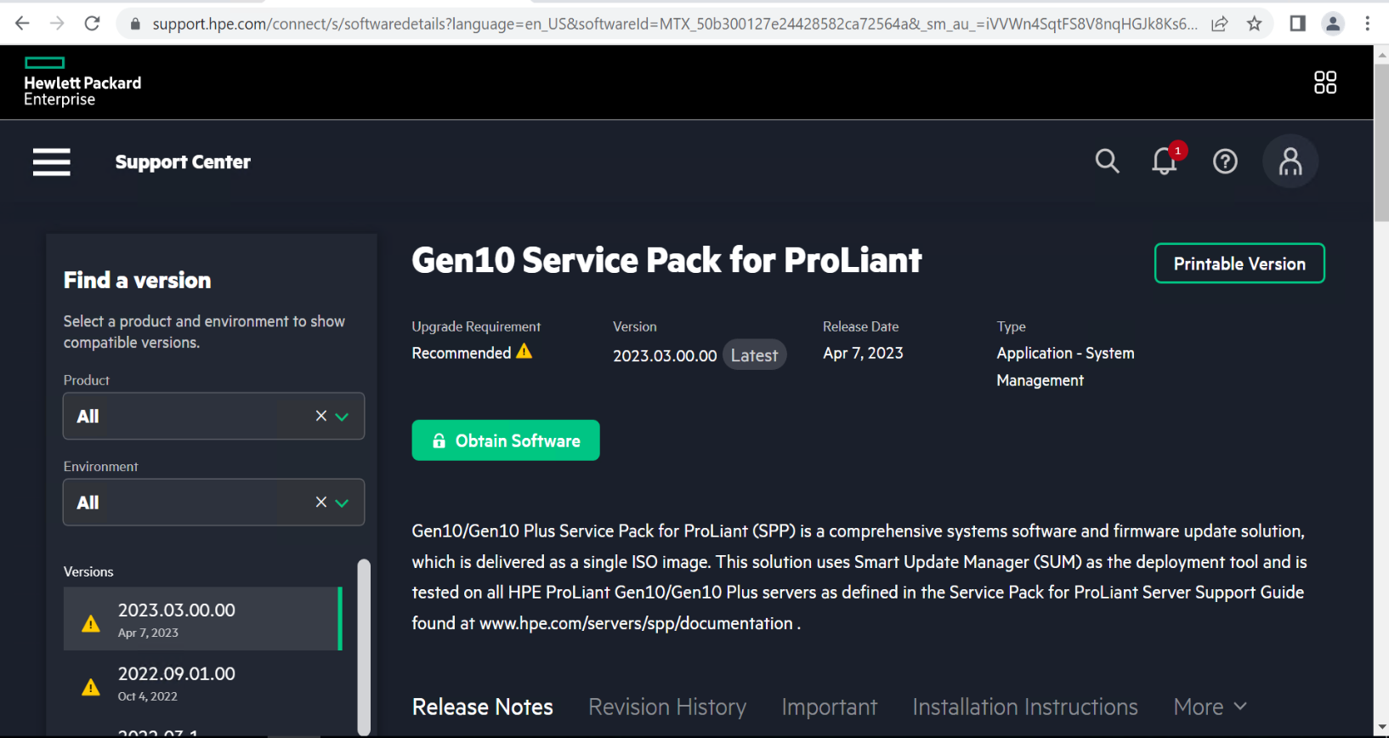
3.1.2 Mount the SSP ISO on the server console
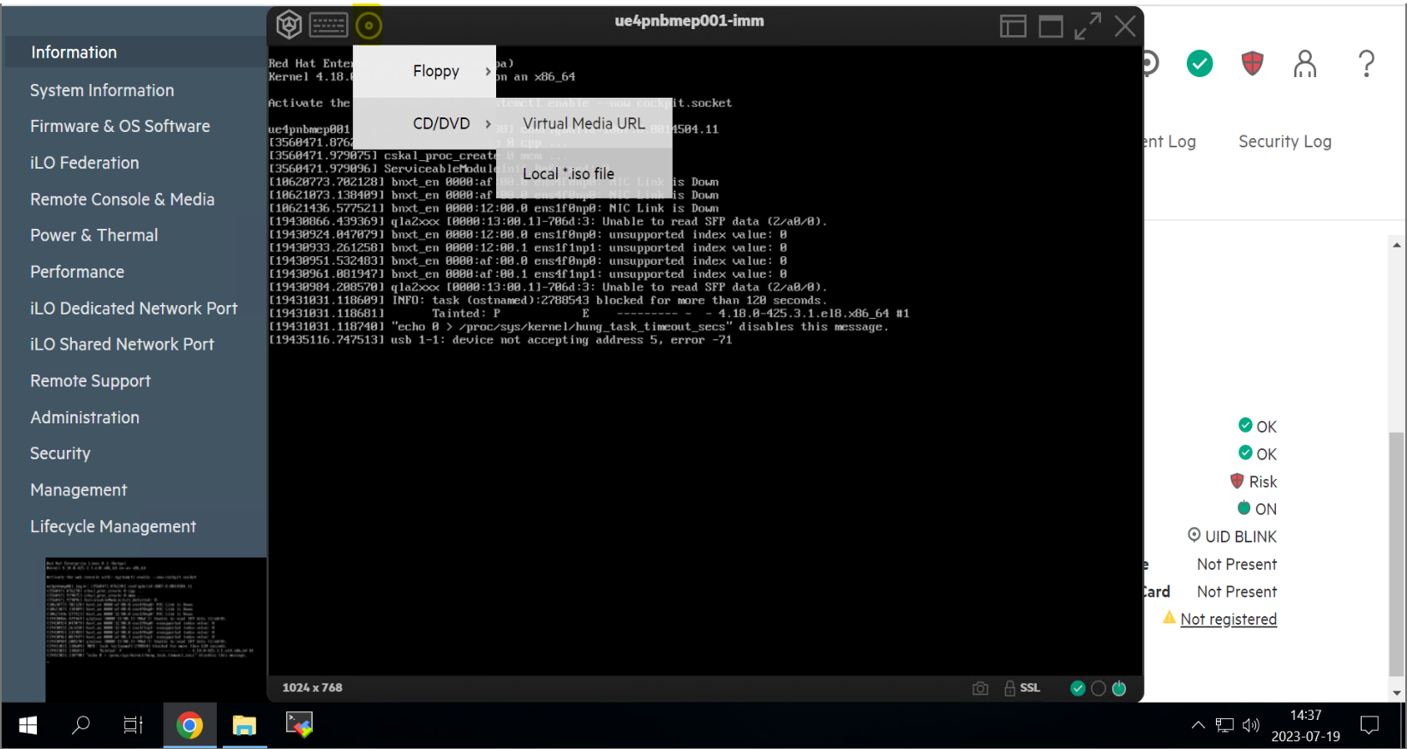
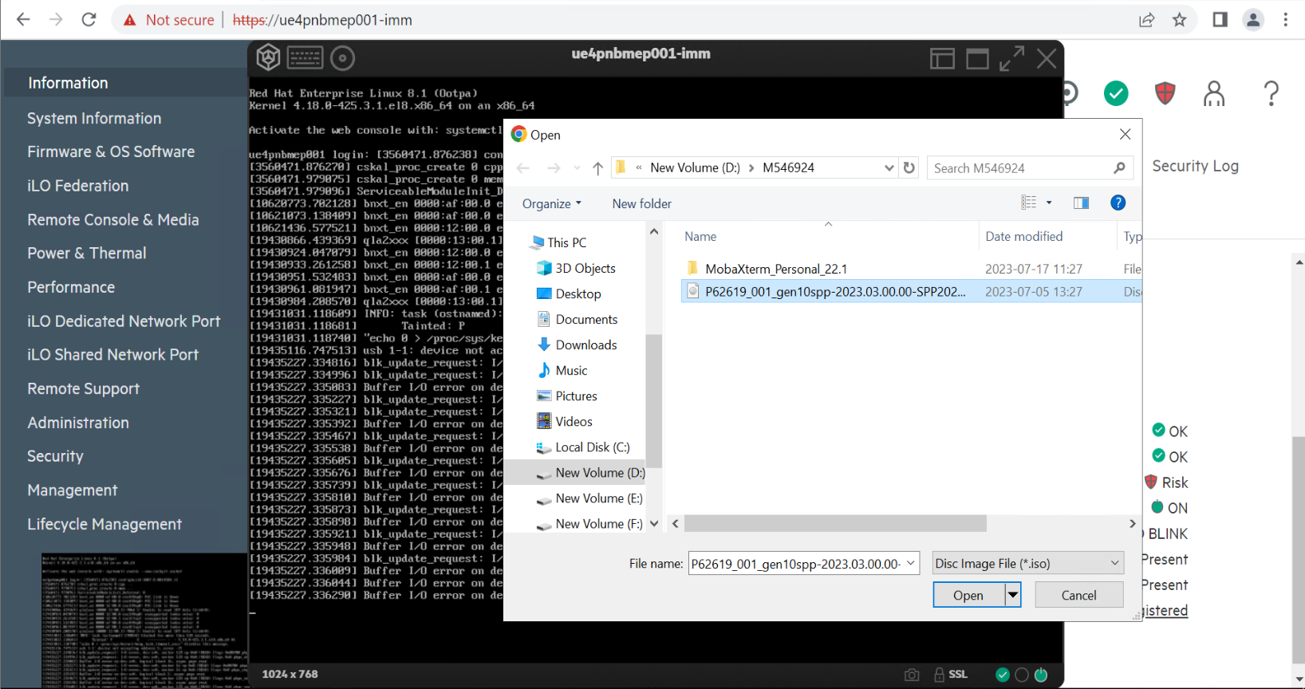

3.1.3 Reboot the server and select F11 (Boot Menu) in the console

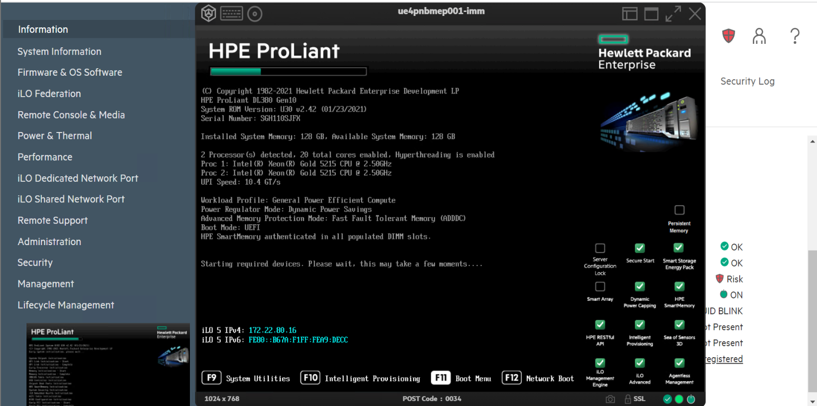

3.2. Step 2

3.2.1 Select One Time Boot Menu
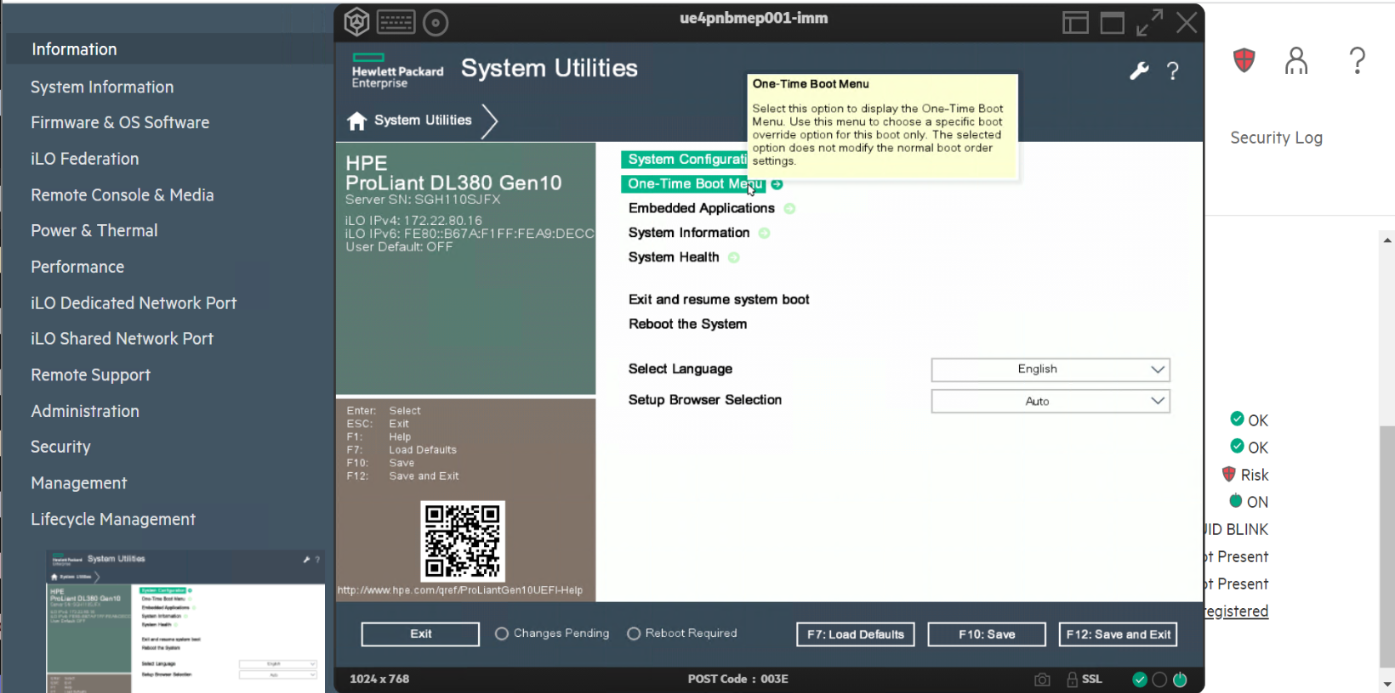

3.2.2 Select the CD-ROM to boot from ISO
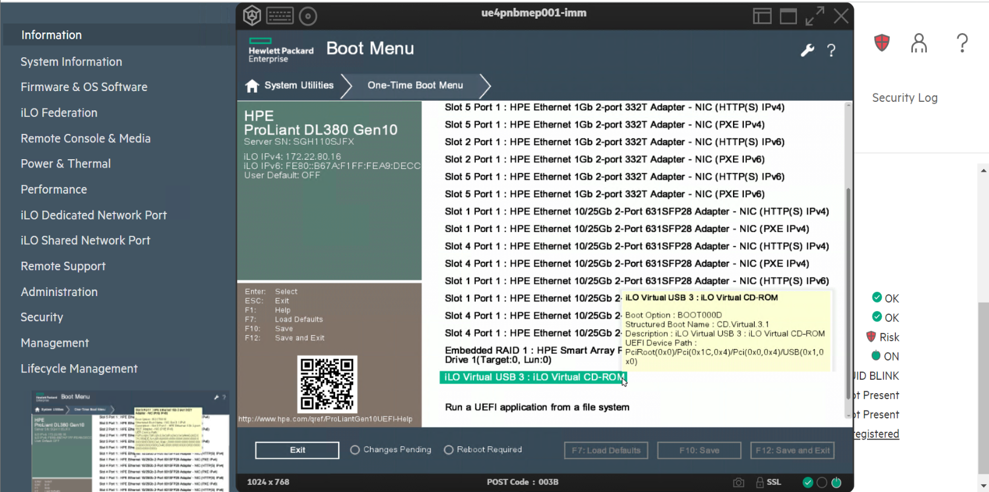

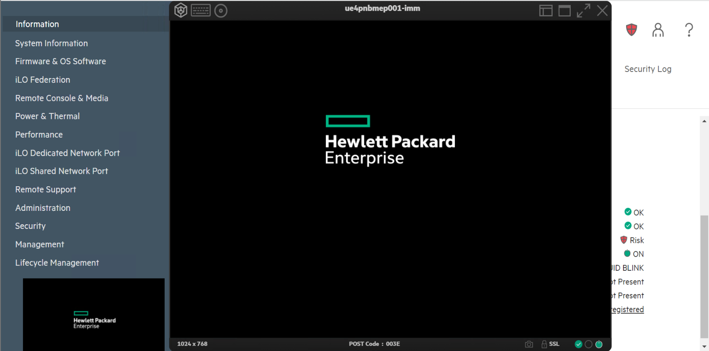

3.2.3 There are two ways to update the firmware
- Automatic Firmware upgrade System will update all the required packages required
- Interactive Firmware upgrade Need to select the required packages to install
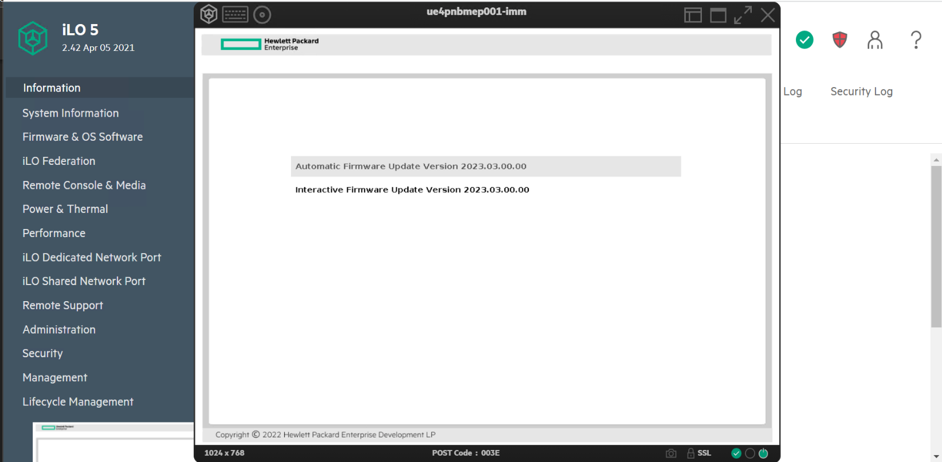

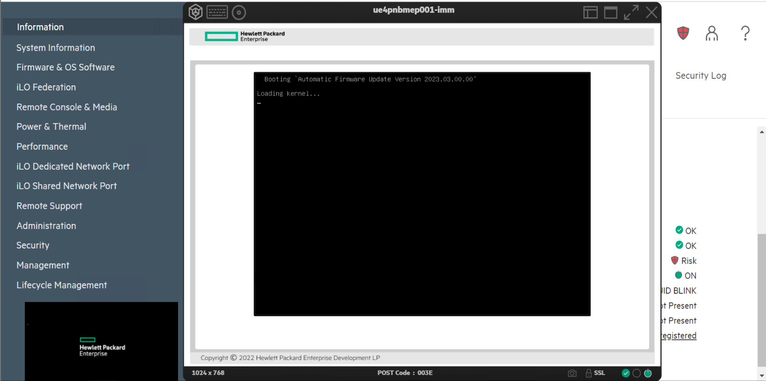

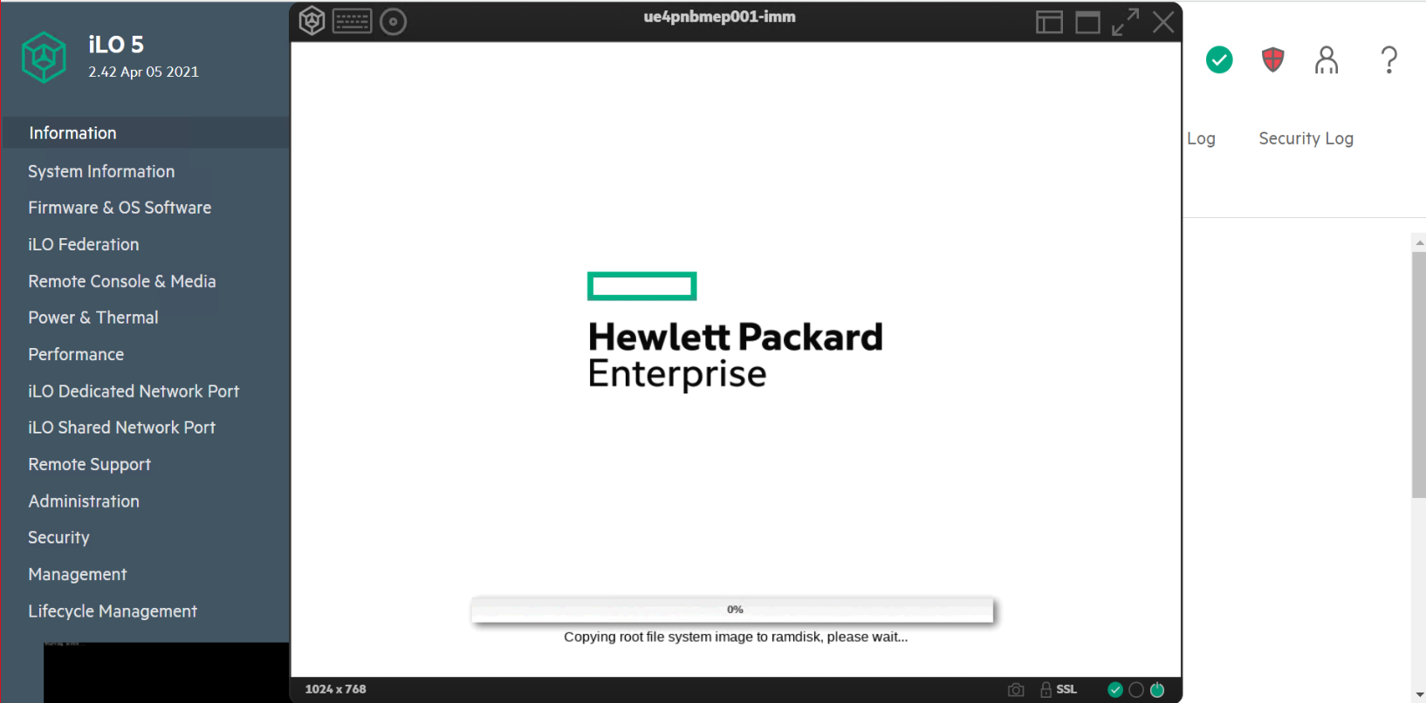

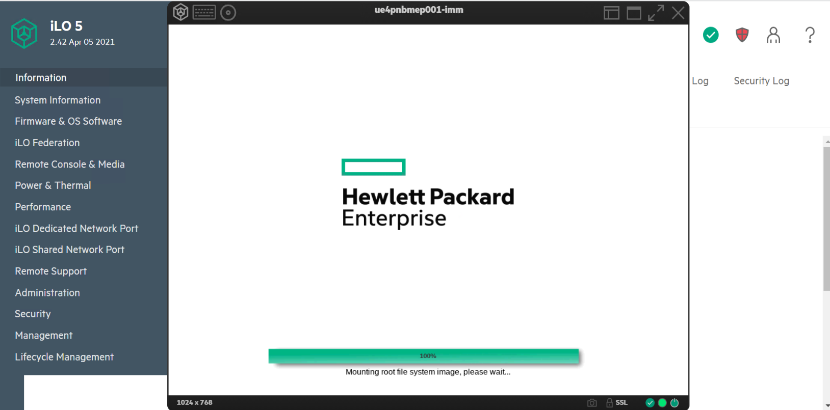

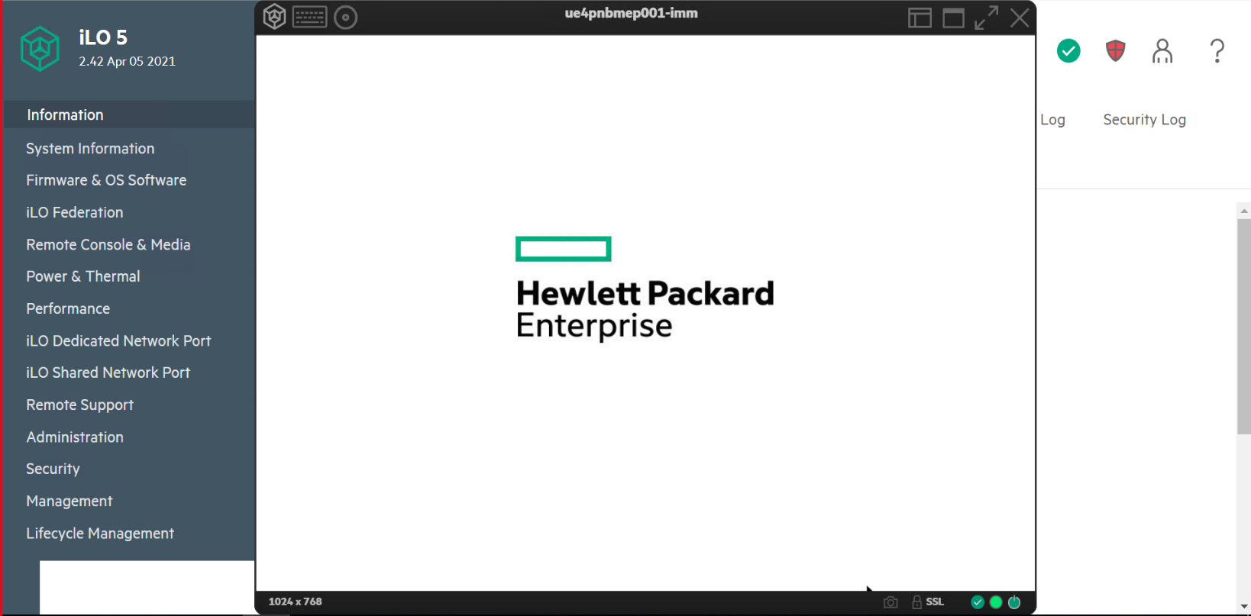

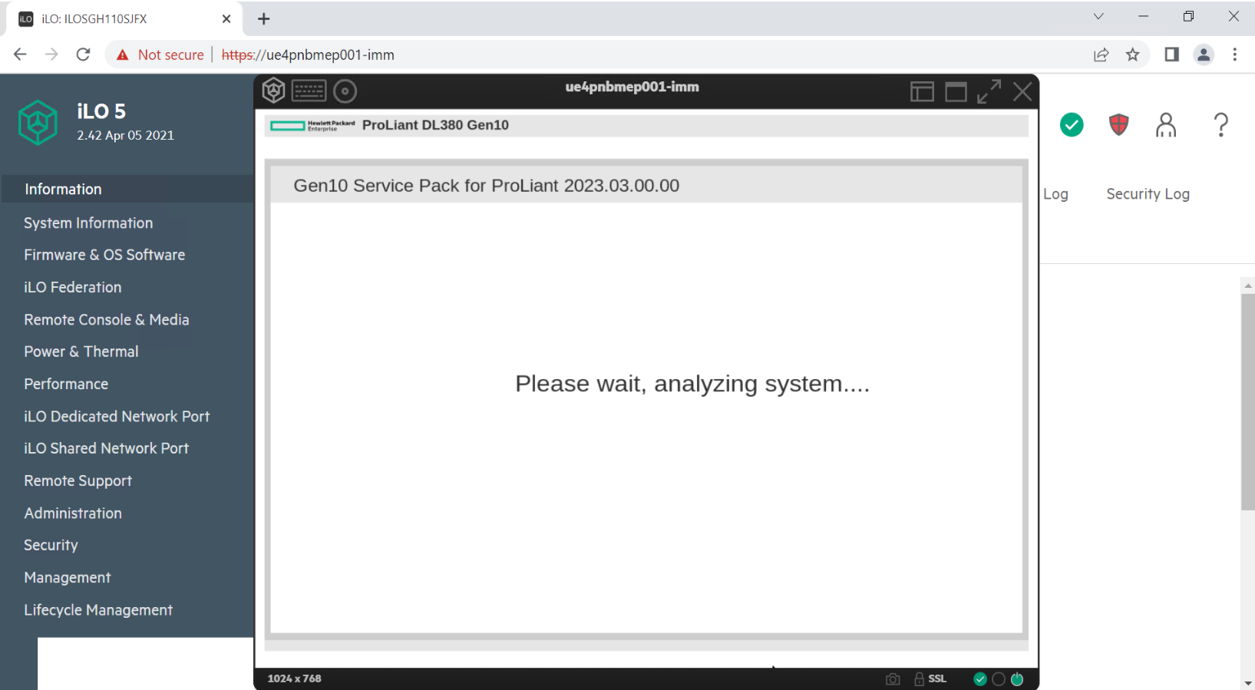

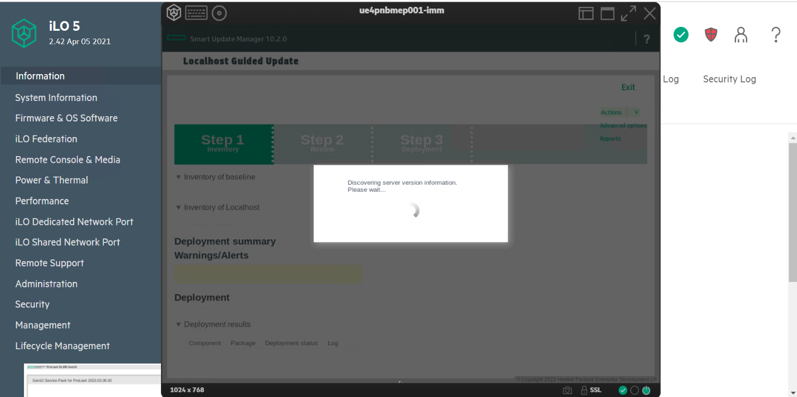

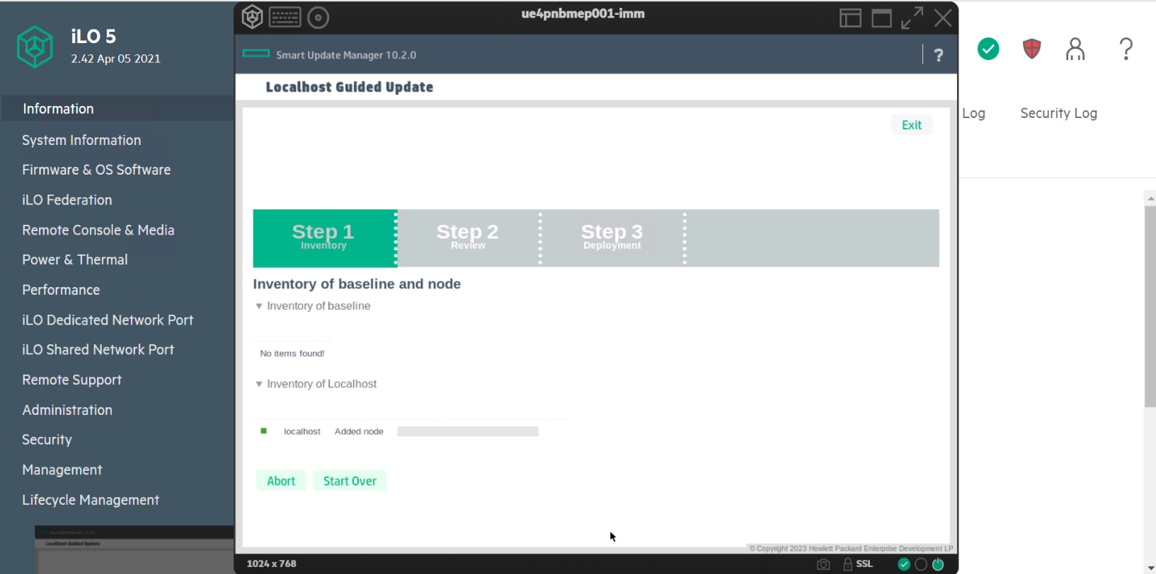

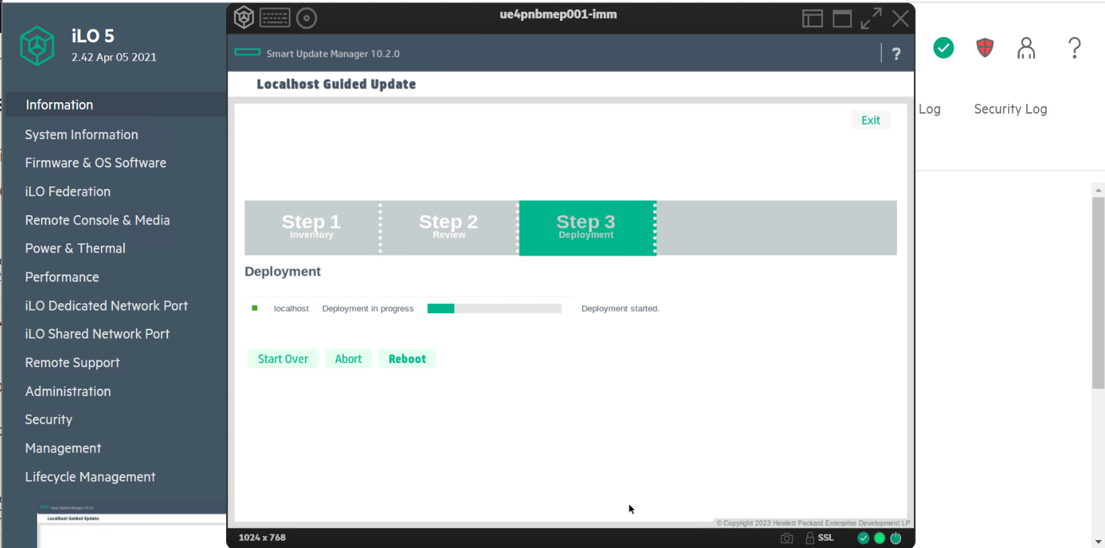

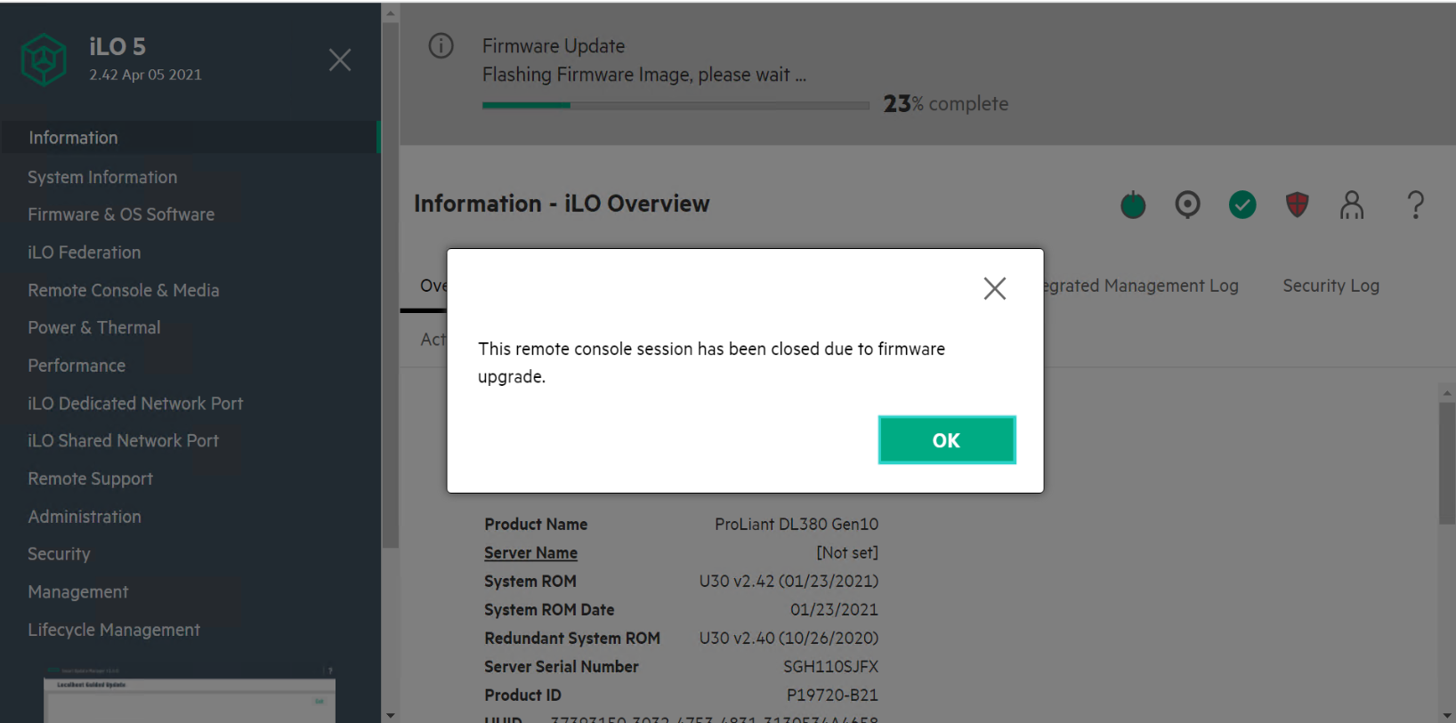

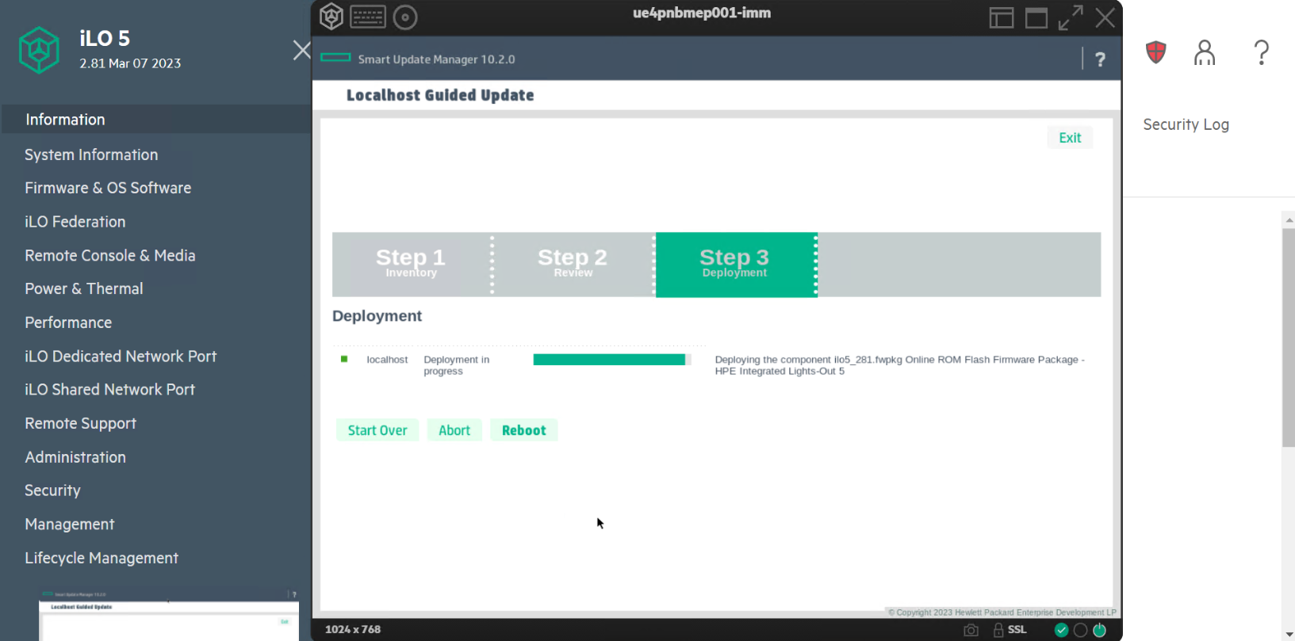

3.3. Step 3
3.3.1. Reboot the server after completing the Deployment
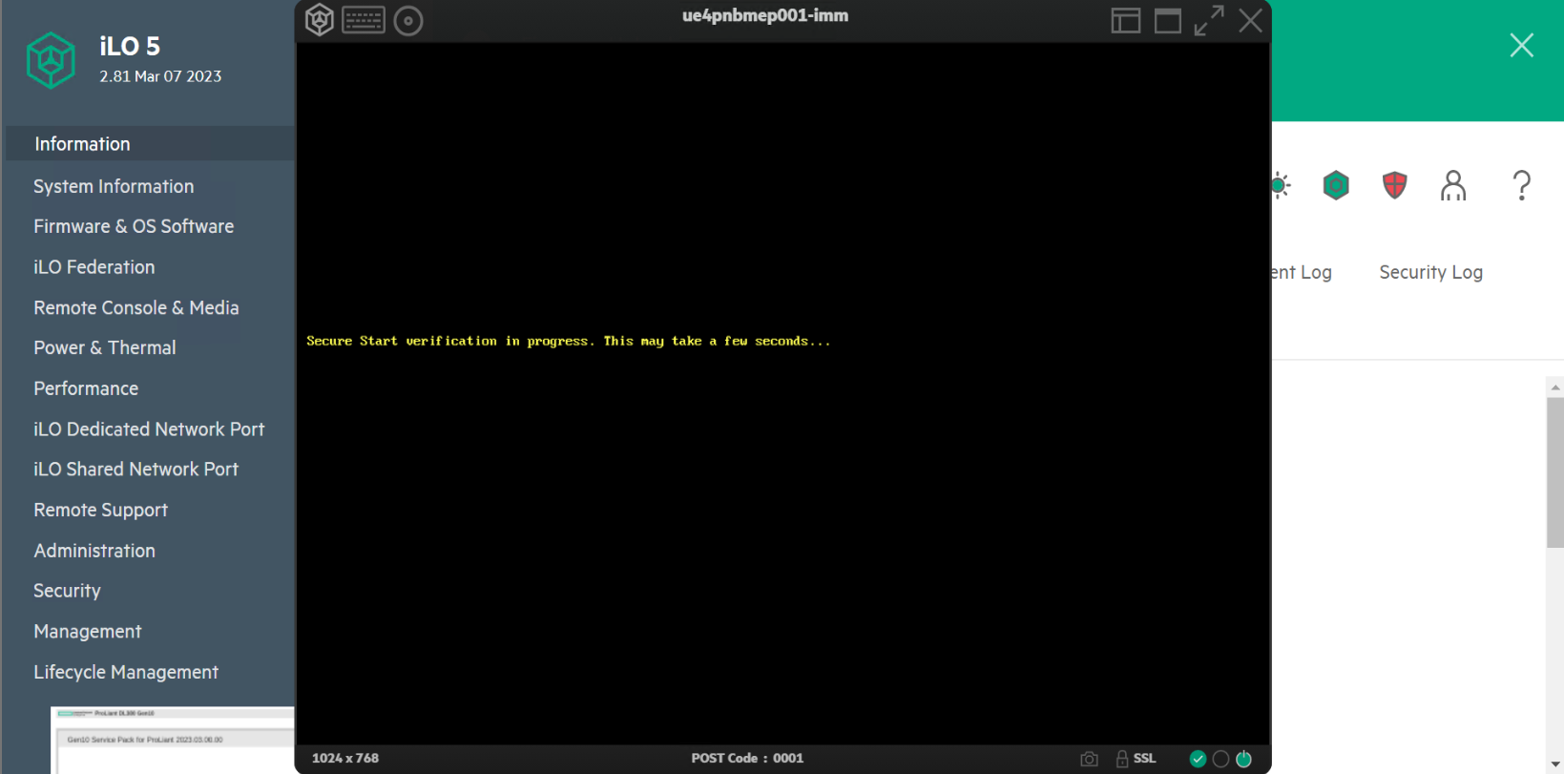

3.3.2. Login to the RHEL and update the operating system
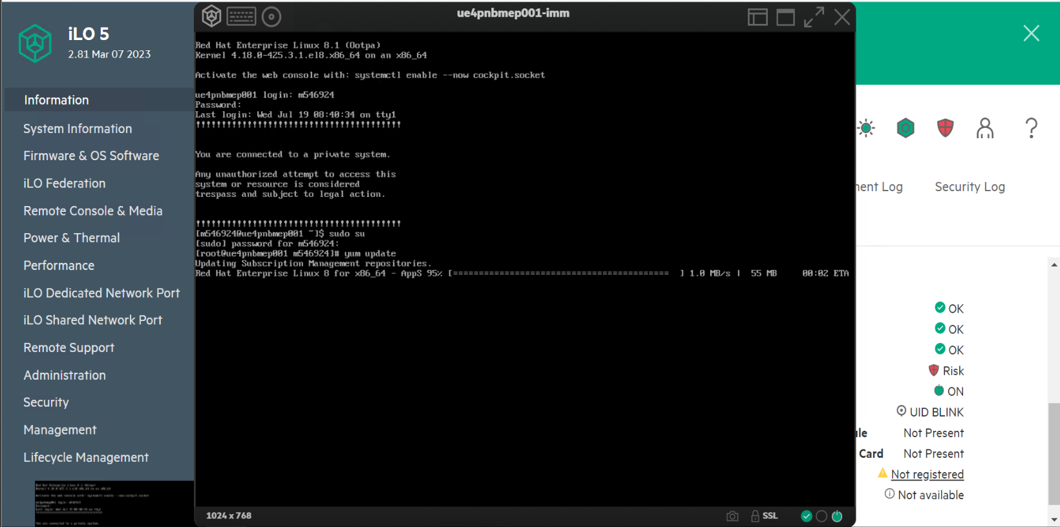

3.3.3. Reboot the operating system after OS update.

Roles and Responsibilities
Sl. No. | Roles | Responsibilities | Team Member Name
1. | Maintenance Window | Respective Team / Unix Team | GIDC.unix_Run  GIDC.unix_Run@viatris.com
2. | Change Request | Respective Team / Unix Team | GIDC.unix_Run  GIDC.unix_Run@viatris.com
3. | Change Implementation | Respective Team / Unix Team | GIDC.unix_Run  GIDC.unix_Run@viatris.com
4. | Hyper Care | Respective Team / Unix Team | GIDC.unix_Run  GIDC.unix_Run@viatris.com

5. Escalation Matrix
Person Responsible | Role | Triggers When
Arun R  Arun.R@viatris.com  +91 9710677240 | SME
Ashok Kumar R K  AshokKumar.RK@viatris.com  +91 9967735890 | Manager
Mohandoss Murugesan  Mohandoss.Murugesan@viatris.com  +91 6366966170 | Senior Manager

6. Related Documentation

6.1. Additional Documentation

7. Version Control
Date | Version | Summary of Changes | Author | Approved by
July 28 2023 | V1.0 | Updated Organization Detail | Ashok Kumar R K | Mohandoss Murugesan

